**Scenario 1:**

Consider a website “FlyTrip.com” used by the customers to book the flight tickets online. Customers can signup/register to book tickets for international and domestic travel. The website helps check the availability of seats based on a source and destination city on a given date.

Here are some assumptions considered for this scenario

* The website allows customers to book tickets multiple times
* Customers can choose the seats such as economy class, business class while booking the ticket
* The flight charges are based on the source and destination and include the charges for the travel class seat chosen at the time of booking.

Here is the database design used by the developers of the website.

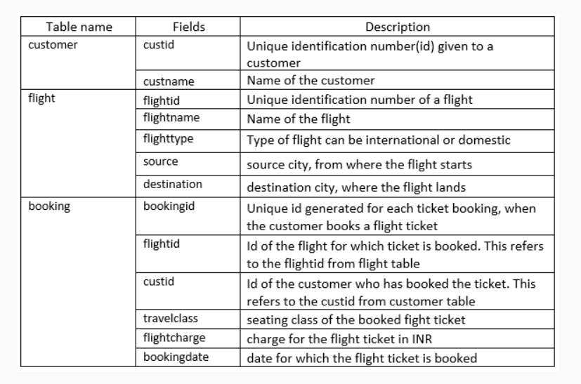

Here is the sample data in the tables.

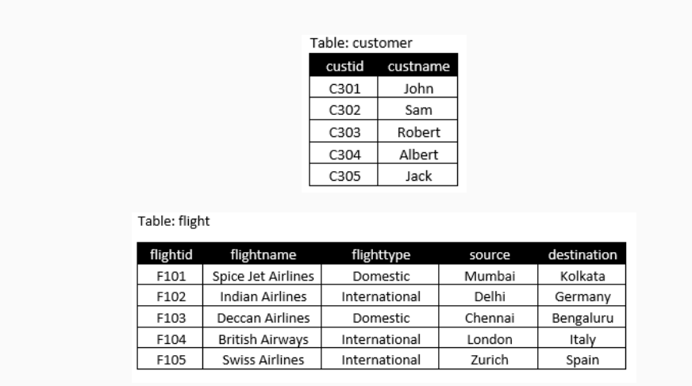

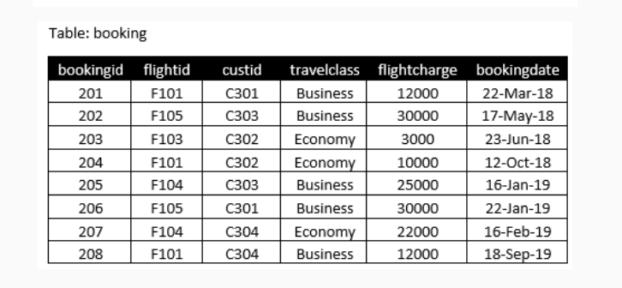

**Requirement 1 :**

Identify the customer(s) who have paid the highest flight charge for the travel class economy. Write a SQL query to display id and name of the identified customers.

**Requirement 2 :**

Identify the international flight(s) which are booked the maximum number of times. Write a SQL query to display id and name of the identified flights.

**Requirement 3 :**

Write a SQL query to display customer’s id and name of those customers who have paid the flight charge which is more than the average flightcharge for all international flights.

**Requirement 4 :**

Identify the customer(s) who have booked tickets for all types of flights. Write a SQL query to display name of the identified customers.

Note: The types of flight are not only the ones defined in the sample data.